Pollution control Board

**1-**

[**http://pcbh.gissoft.net/pollution/regpulldata**](http://pcbh.gissoft.net/pollution/regpulldata)

(Display necessary value for registration page like districts and state)

**Notice: Use GET request**

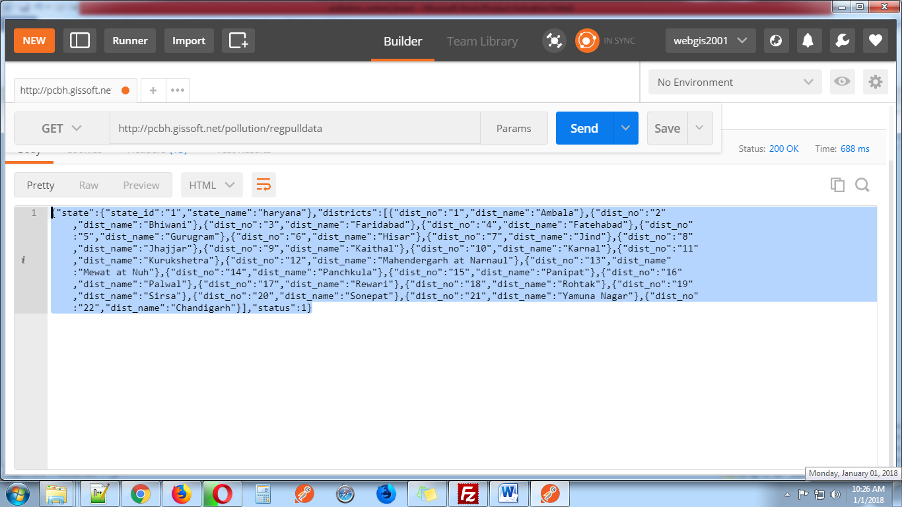

**2-** [**http://pcbh.gissoft.net/pollution/registration**](http://pcbh.gissoft.net/pollution/registration)

(This web service use for member registration this web service use these parameter)

**1-** **organization (pass organization name)**

**2- applicant_name (pass user name)**

**3- father_name (pass user father name)**

**4- address1 (pass user address)**

**5- address2 (pass user second address)**

**6- state(pass state id) (get from first web services)**

**7- district (pass district id)**

**8- applicant_email (pass user email)**

**9- applicant_mobile (pass user mobile number)**

**10- gender (pass member gender)(format: M/F)**

**11-device_token (pass mobile device token)**

**Notice: Send all these parameters with POST request**

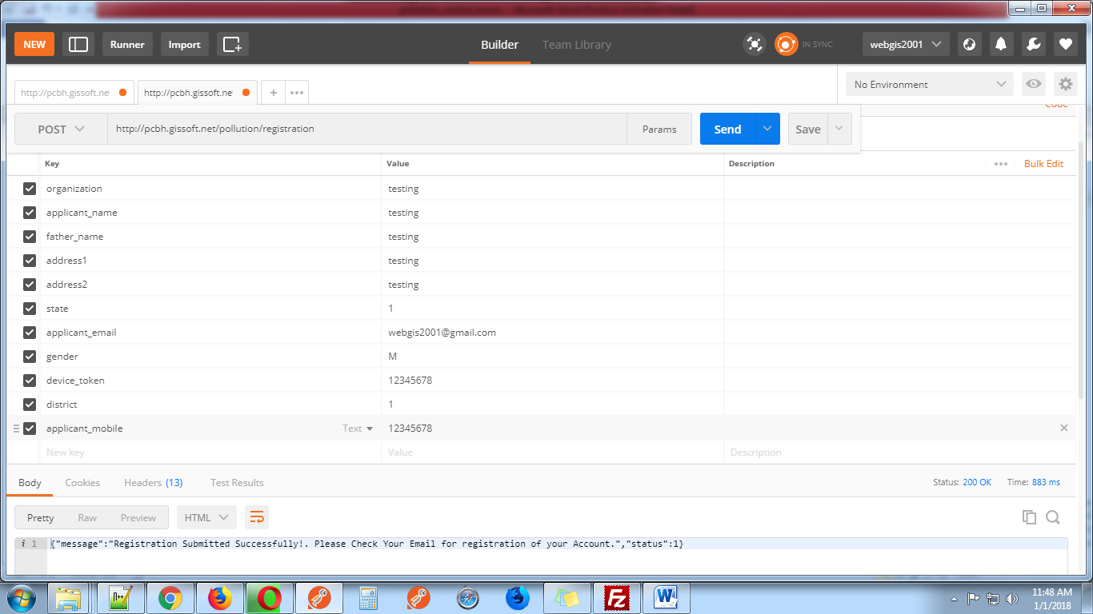

**3-**

[**http://pcbh.gissoft.net/pollution/login**](%20http://pcbh.gissoft.net/pollution/login)

This web services use for login. This web services use these parameter.

**1-** **applicant_email_or_name (Pass user email address or name which send in user email id)**

**2-** **applicant_password (Pass user password)**

**3-** **device_token (Pass device token )**

**Notice: Send these three parameters with POST request**

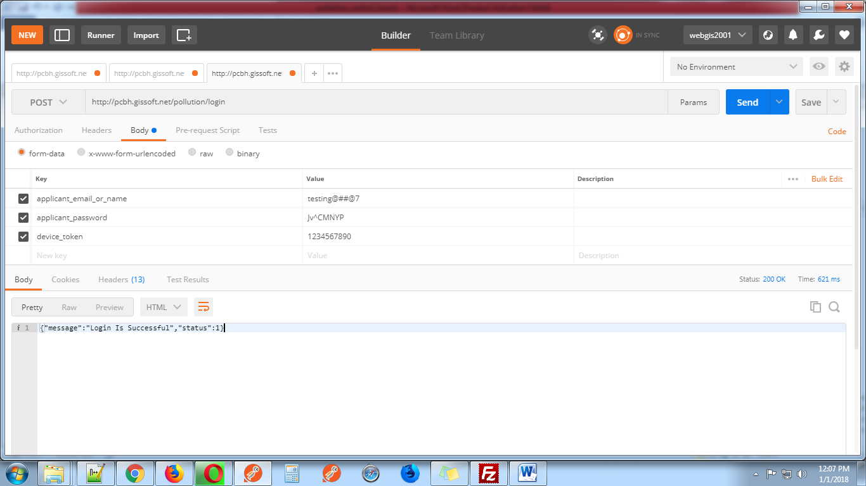

**4-**

[**http://pcbh.gissoft.net/pollution/forget_password**](%20http://pcbh.gissoft.net/pollution/forget_password)

This web services use for forget password. This web services use one parameter.

1. **applicant_email (Pass user email address)**

**Notice: Send parameter with GET request**

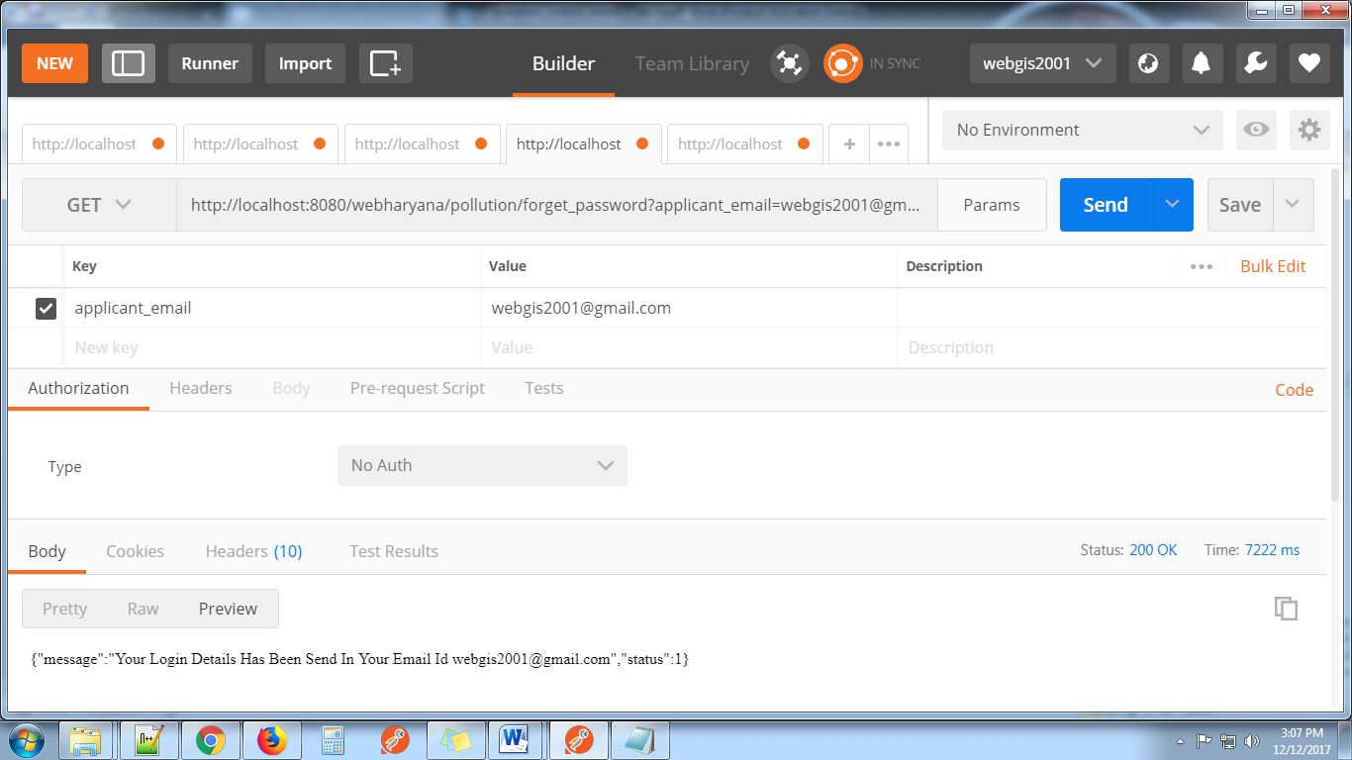

**5-**

[**http://pcbh.gissoft.net/pollution/user_profile**](%20http://pcbh.gissoft.net/pollution/user_profile)

This web services use for display user profile. This web services use two parameters.

1. **applicant_email_or_name (Pass User Email address or User Name which send in user email id)**
2. **device_token(Pass Device Token )**

**Notice: Send both parameters with GET request**

This web services display user details like email id, state, district, organization, name, father name, mobile number, address1,address2,gender

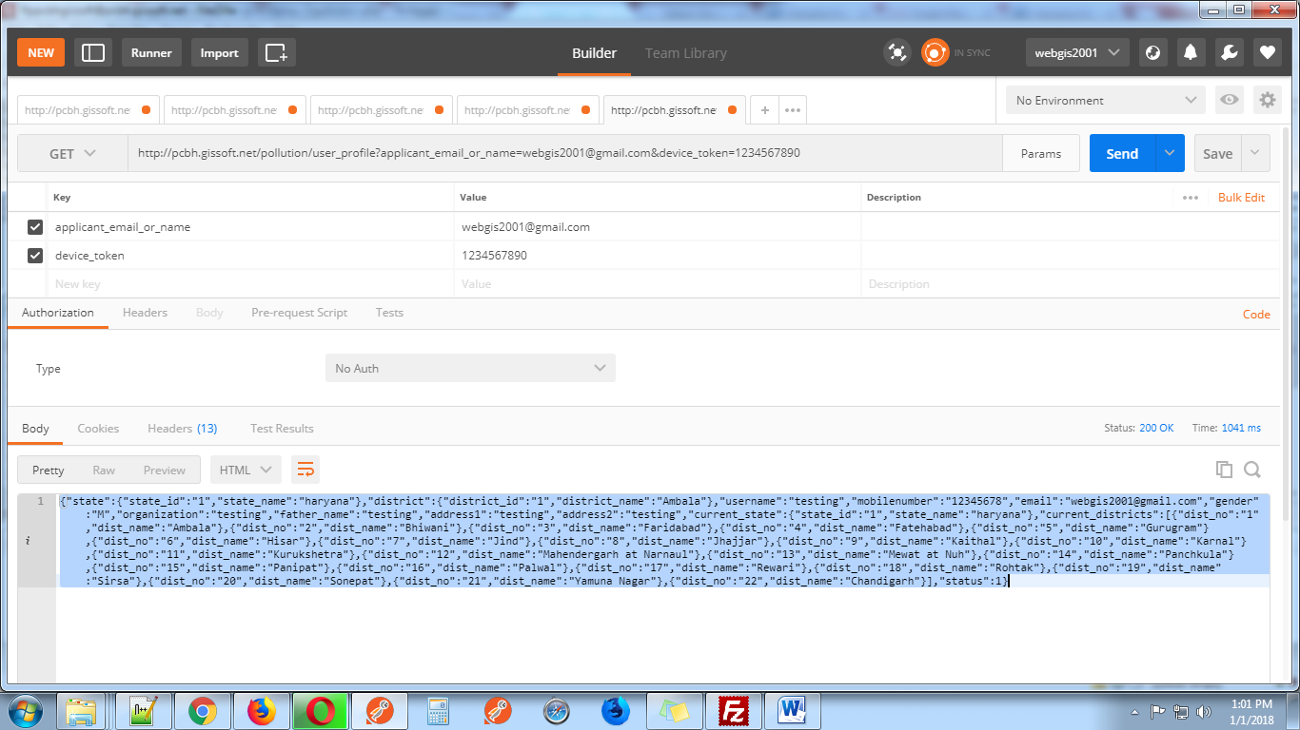

**6-**

[**http://pcbh.gissoft.net/pollution/update_user_profile**](%20http://pcbh.gissoft.net/pollution/update_user_profile)

This web services use for update user profile. This web services use these parameters.

1. **applicant_email_or_name(Pass User Email address or User Name which send in user email id)**
2. **device_token**
3. **district_id**
4. **applicant_name**
5. **applicant_mobile**
6. **gender**
7. **organization**
8. **father_name**
9. **address1**
10. **address2**

**Notice: Send these parameters with POST request. Display user email is not editable.**

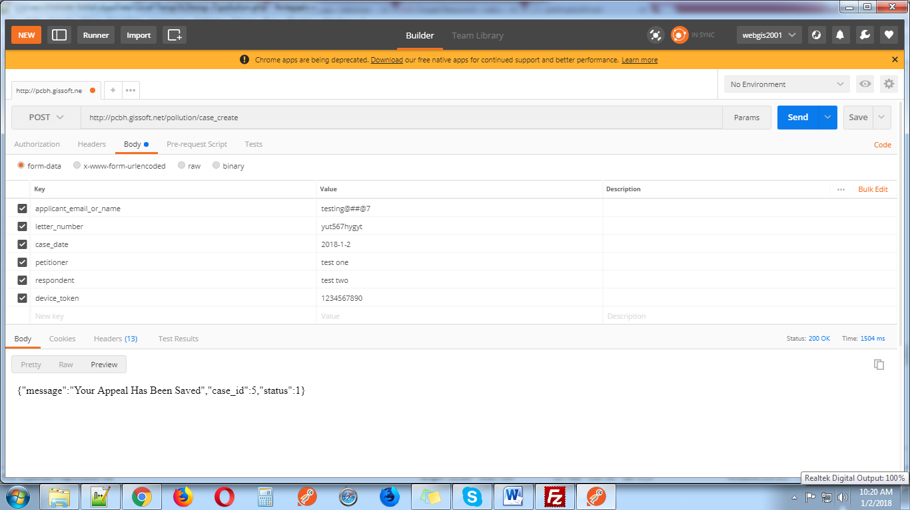

**7-**  [**http://pcbh.gissoft.net/pollution/case_create**](%20http://pcbh.gissoft.net/pollution/case_create)

This web services use for send user Appeal. This web services use these parameters.

1. **applicant_email_or_name (Pass User Email address or User Name which send in user email id)**
2. **device_token**
3. **letter_number (Pass Unique Letter Number)**
4. **case_date (Pass Appeal Date)**
5. **petitioner (Pass petitioner name)**
6. **respondent (Pass respondent name)**

**Notice: Send these parameters with POST request. After send request user got case_id in response.This case_id use for upload attachment.**

**{"message":"Your Appeal Has Been Saved","case_id":1,group_id:3,"status":1}**

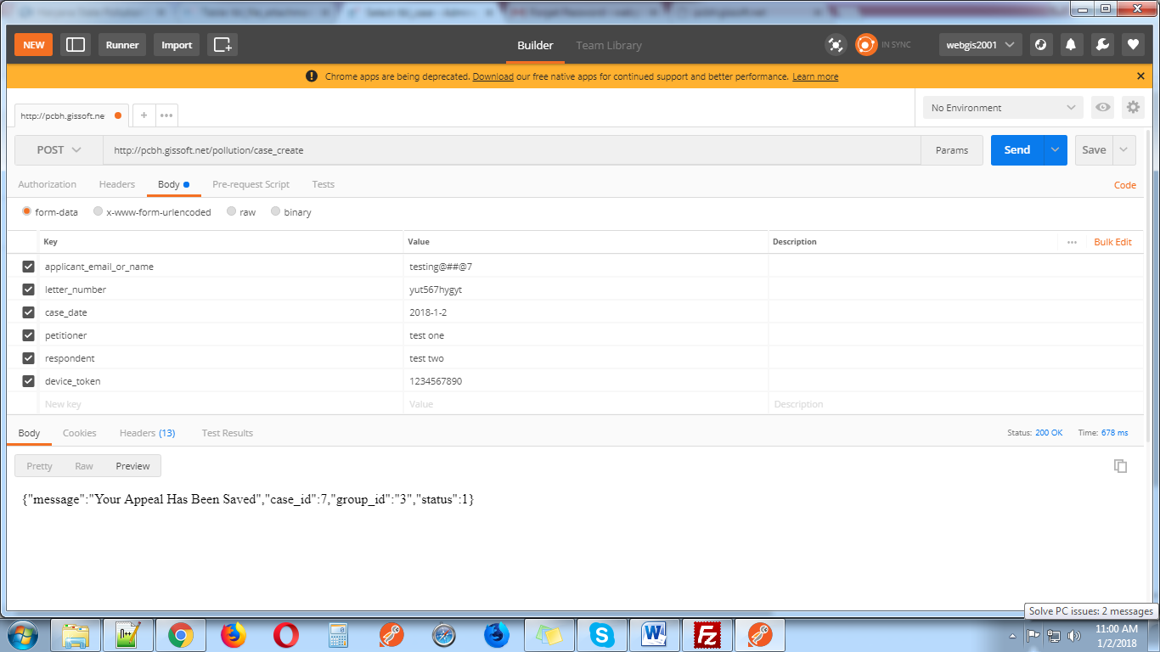

**8-**  [**http://pcbh.gissoft.net /pollution/upload_attechment**](http://localhost:8080/webharyana/pollution/upload_attechment)

This web services use for upload PDF file. This web services use these parameters.

1. **applicant_email_or_name**
2. **device_token**
3. **case_id**
4. **appeal_pdf**

**Notice: Send these parameters with POST request with case_id which get from previous request.**

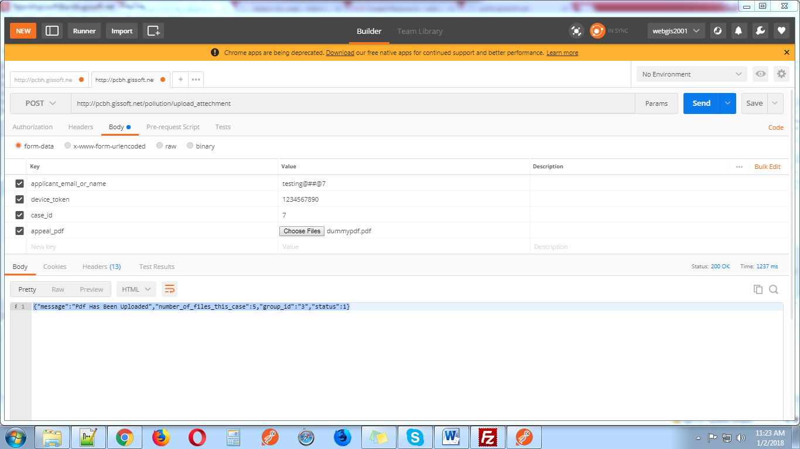

**9-** [**http://pcbh.gissoft.net/pollution/appeal**](http://pcbh.gissoft.net/pollution/appeal)

This web services display case with permission for

1-Super admin can manage all case. He can view, saw attachments, edit ,Assign, Hearing, Dispose Off and Decided the case

2-Admin can work on those case which assign by super admin. He can view, saw attachments, Hearing, Dispose Off and Decided the case

3-Use can view his case and edit case when case status in pending.

This web services use five parameters. These parameters pass with get request.

1. **applicant_email_or_name**
2. **device_token**
3. **group_id** (1 for super admin 2 for admin 3 for user)
4. **offset(for limit first time pass 0)**
5. **limit(for display number of rows)**

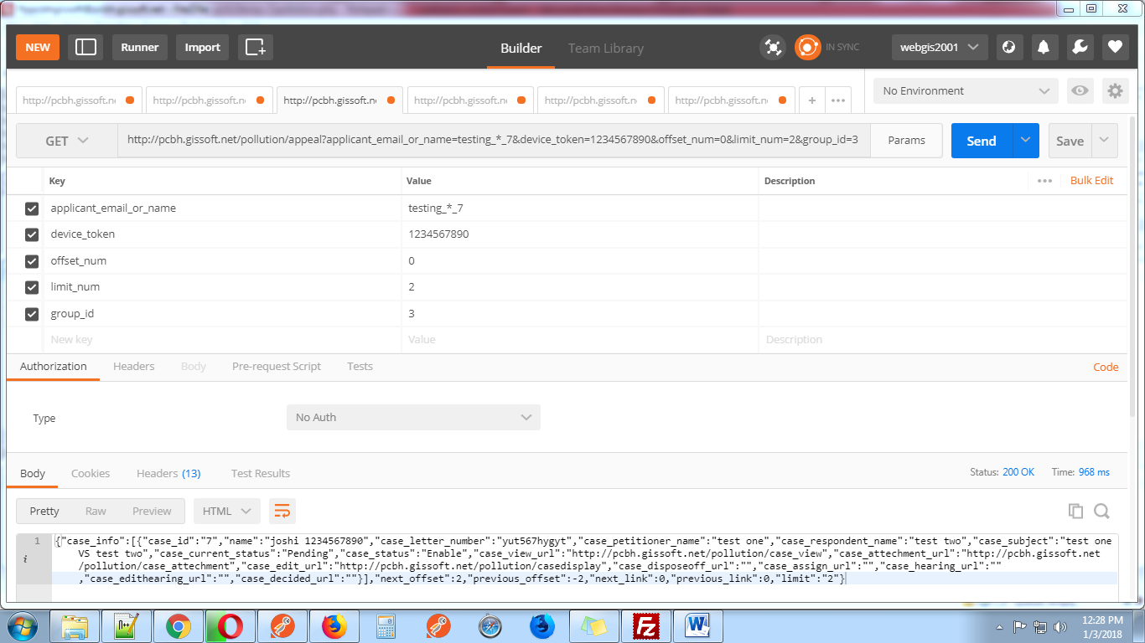

**10-** [**http://pcbh.gissoft.net/pollution/caseview**](http://pcbh.gissoft.net/pollution/caseview)

This web services display case with current status like assign details, hearing details etc.

Parameters details.

1. **applicant_email_or_name**
2. **device_token**
3. **group_id** (1 for super admin 2 for admin 3 for user)
4. **case_id**

These parameters pass with get request.

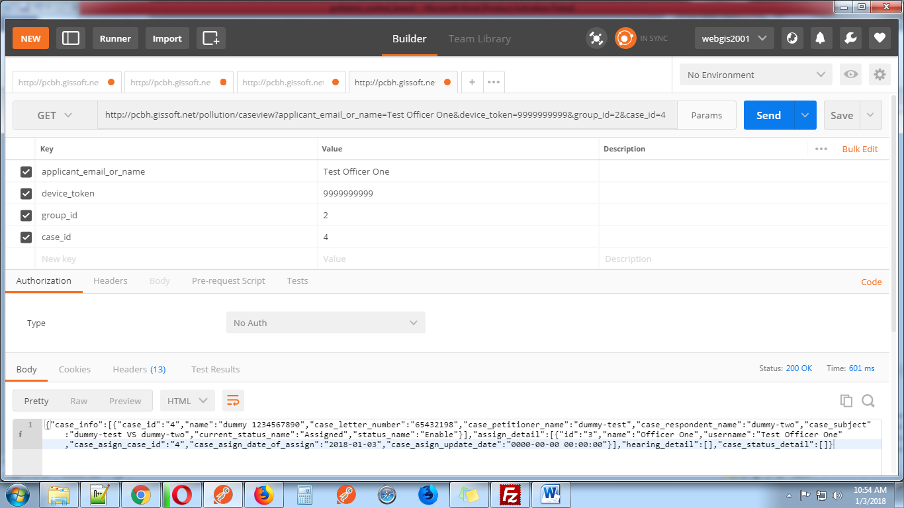

**11-** [**http://pcbh.gissoft.net/pollution/casedisplay**](http://pcbh.gissoft.net/pollution/casedisplay)

This web services display case information for edit when case is pending case edit by user and super admin.

Parameters details.

1. **applicant_email_or_name**
2. **device_token**
3. **group_id** (1 for super admin 2 for admin 3 for user)
4. **case_id**

These parameters pass with get request.

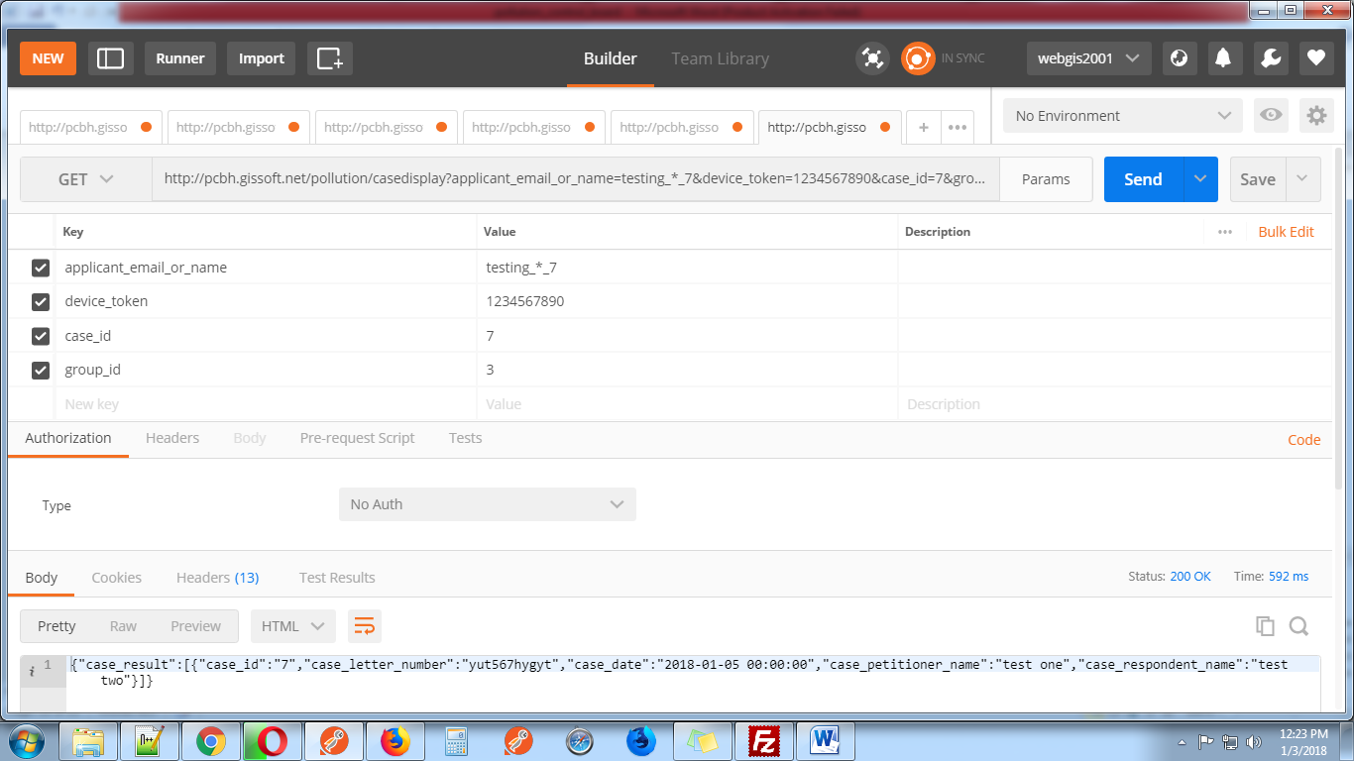

**12-** [**http://pcbh.gissoft.net/pollution/caseedit**](http://pcbh.gissoft.net/pollution/caseedit)

This web services use for edit case for pending case by user and super admin

Parameters details.

1. **applicant_email_or_name**
2. **device_token**
3. **group_id** (1 for super admin 2 for admin 3 for user)
4. **case_id**
5. **case_letter_number**
6. **case_petitioner_name**
7. **case_respondent_name**
8. **case_date**

These parameters pass with post request.

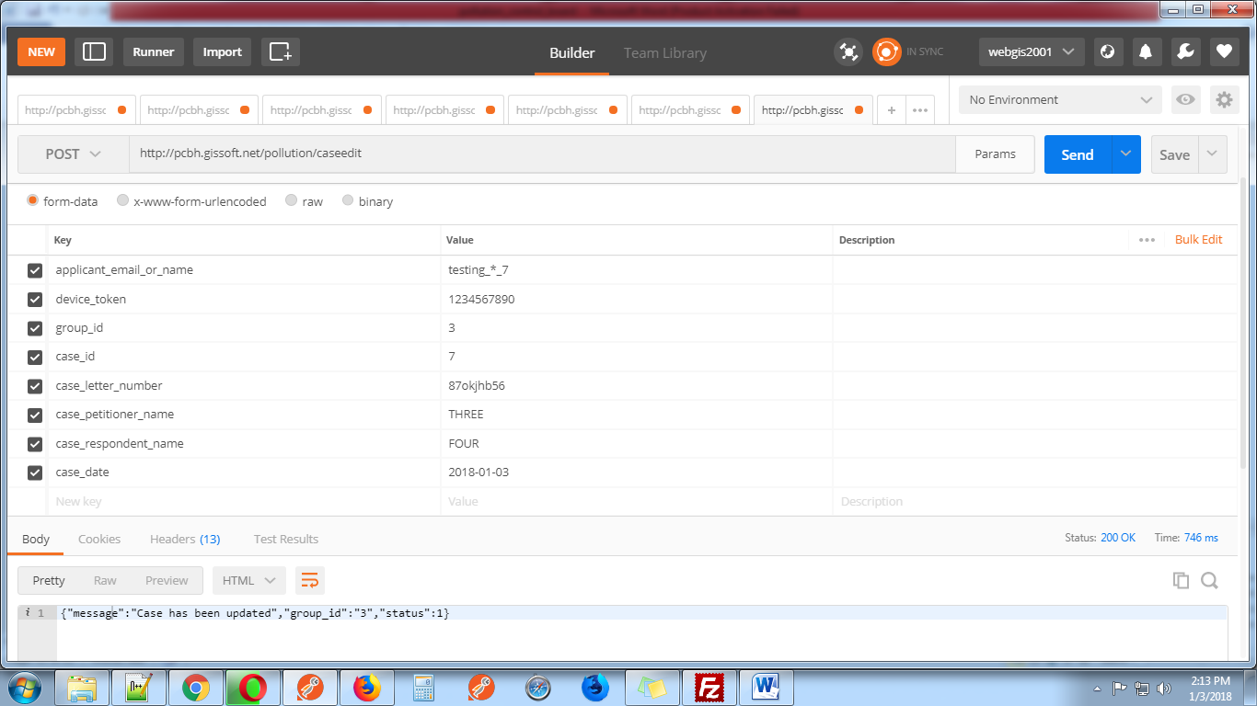

**13-** [**http://pcbh.gissoft.net/pollution/caseattechment**](http://pcbh.gissoft.net/pollution/caseattechment)

This web services display case attachment

Parameters details.

1. **applicant_email_or_name**
2. **device_token**
3. **group_id** (1 for super admin 2 for admin 3 for user)
4. **case_id**

These parameters pass with get request.

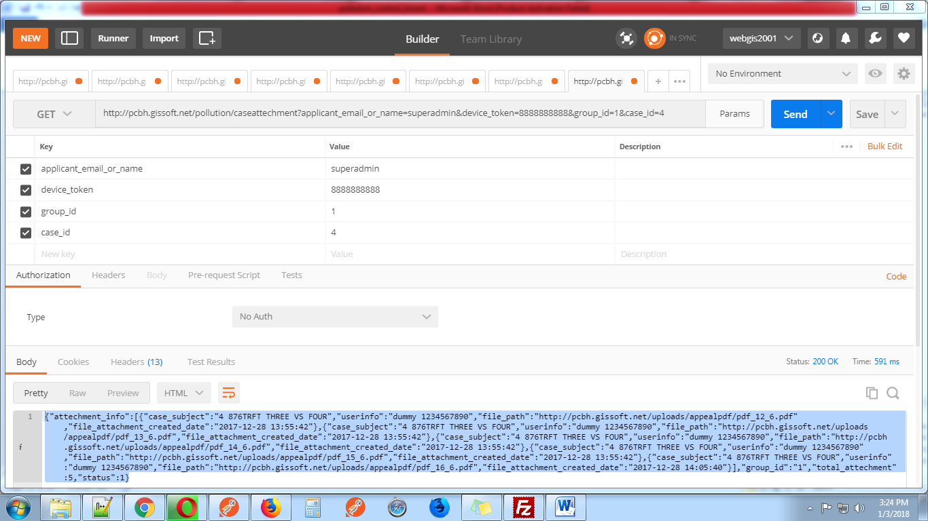

**14-**[**http://pcbh.gissoft.net/pollution/casedisposeoff**](http://pcbh.gissoft.net/pollution/casedisposeoff)

This web services display case info for dispose_off page like case subject (case_id, letter number, subject) and officer name.

Parameters details.

1. **applicant_email_or_name**
2. **device_token**
3. **group_id** (1 for super admin 2 for admin 3 for user)
4. **case_id**

These parameters pass with get request.

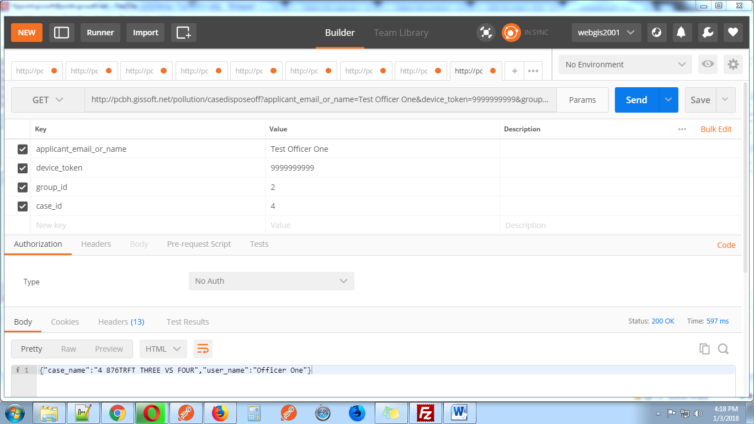

**15-**[**http://pcbh.gissoft.net/pollution/casedecided**](http://pcbh.gissoft.net/pollution/casedisposeoff)

This web services display case info for decided page like case subject (case_id, letter number, subject) and officer name. In this page Pdf Upload show with date and remark.

Parameters details.

1. **applicant_email_or_name**
2. **device_token**
3. **group_id** (1 for super admin 2 for admin 3 for user)
4. **case_id**

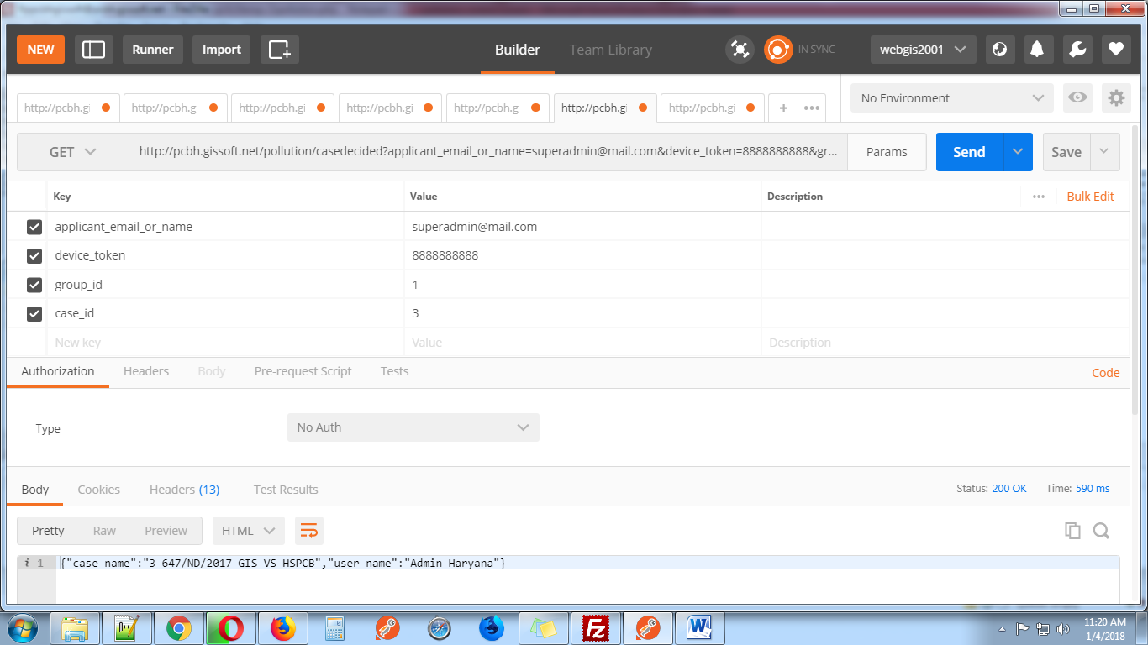

**16-** [**http://pcbh.gissoft.net/pollution/savedisposeoffandcasedecided**](http://pcbh.gissoft.net/pollution/savedisposeoffandcasedecided)

This web services use for action case disposeoff and case decided.

For disposeoff send these parameters with post request.

1. **applicant_email_or_name**
2. **device_token**
3. **group_id** (1 for super admin 2 for admin 3 for user)
4. **case_id**
5. **status_type(disposeoff)**
6. **date (YYYY-mm-dd format)**
7. **remark**

For decided send these parameters with post request.

1. **applicant_email_or_name**
2. **device_token**
3. **group_id** (1 for super admin 2 for admin 3 for user)
4. **case_id**
5. **status_type(decided)**
6. **date (YYYY-mm-dd format)**
7. **attachment(upload only pdf file with less then 5MB)**
8. **remark**

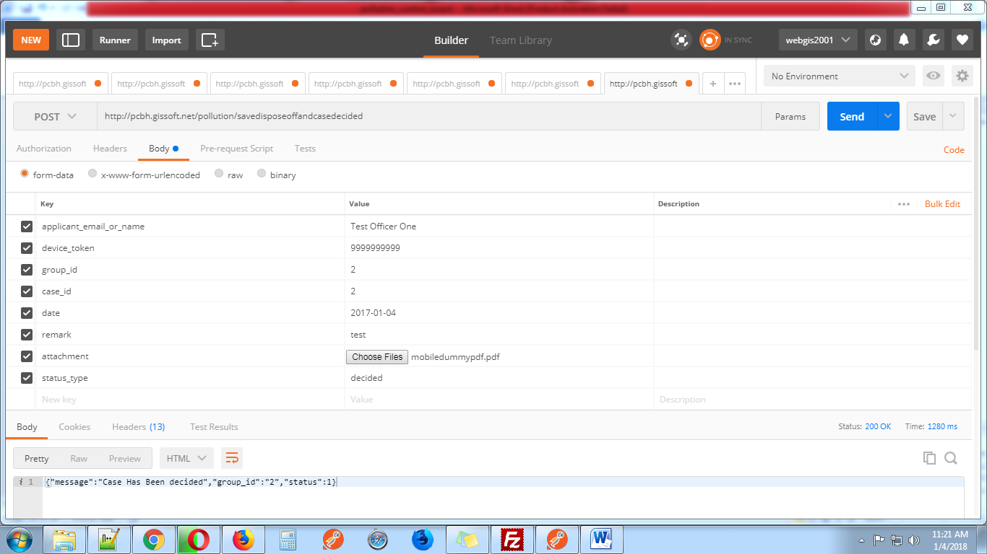

**17-** [**http://pcbh.gissoft.net/pollution/caseassign**](http://pcbh.gissoft.net/pollution/caseassign)

This web services use for display case assign page. This web services display case subject (case_id, letter_number, subject) and officers name with id.

Send these parameters with post request.

1. **applicant_email_or_name**
2. **device_token**
3. **group_id** (1 for super admin 2 for admin 3 for user)
4. **case_id**

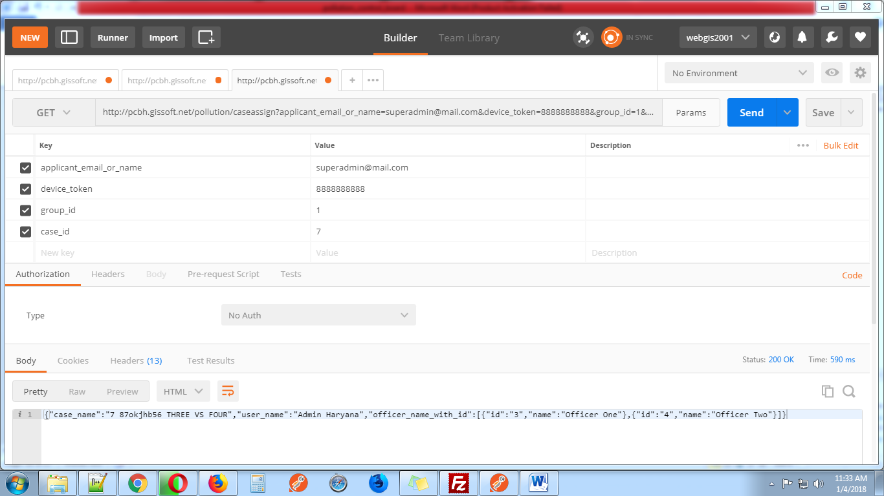

**18-** [**http://pcbh.gissoft.net/pollution/savecaseassign**](http://pcbh.gissoft.net/pollution/savecaseassign)

This web services use for action case assign by super admin

Send these parameters with post request.

1. **applicant_email_or_name**
2. **device_token**
3. **group_id** (1 for super admin 2 for admin 3 for user)
4. **case_id**
5. **officer_id(officer id send from** [**http://pcbh.gissoft.net/pollution/caseassign**](http://pcbh.gissoft.net/pollution/caseassign) **web services)**
6. **case_asign_date_of_assign(YYYY-mm-dd)**

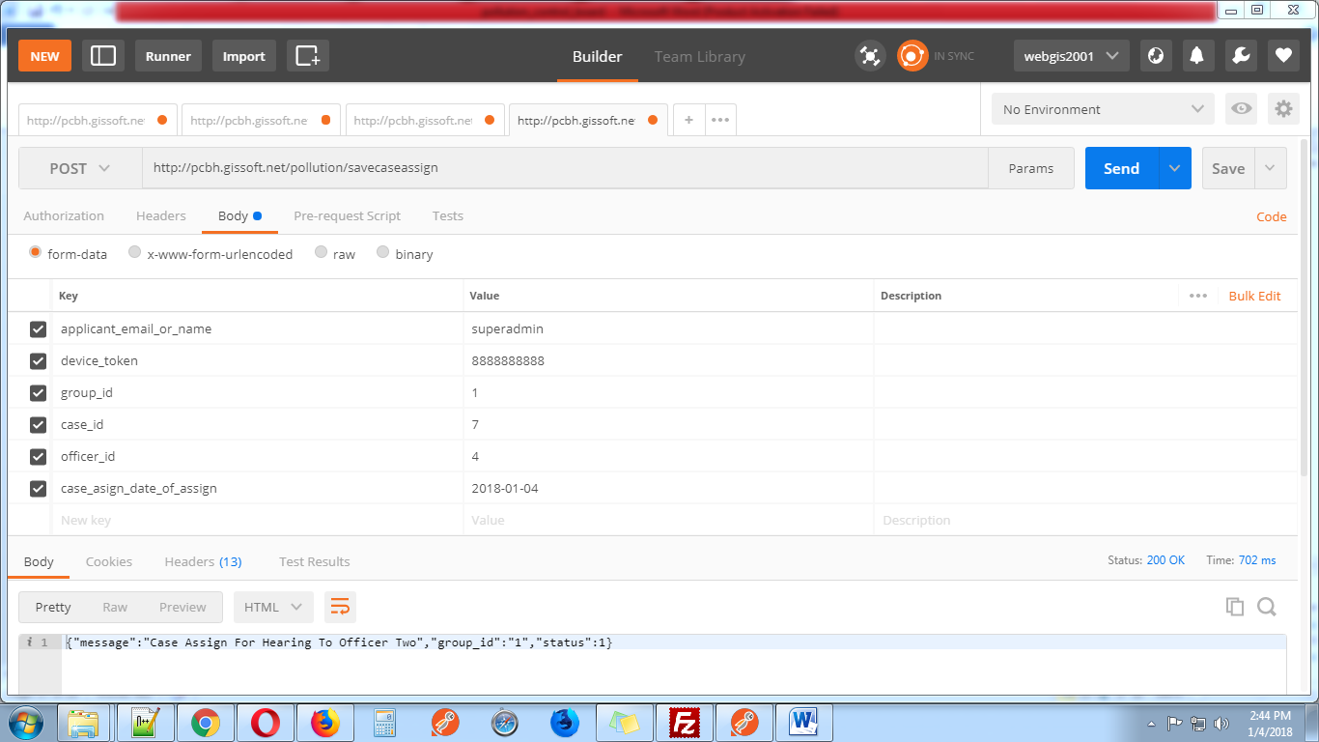

**19-** [**http://pcbh.gissoft.net/pollution/casehearing**](http://pcbh.gissoft.net/pollution/casehearing)

This web services use for display case hearing page. This web services display case subject (case_id, letter_number, subject) and officers name with id, case status with id and addresses with id.

Send these parameters with get request.

1. **applicant_email_or_name**
2. **device_token**
3. **group_id** (1 for super admin 2 for admin 3 for user)
4. **case_id**

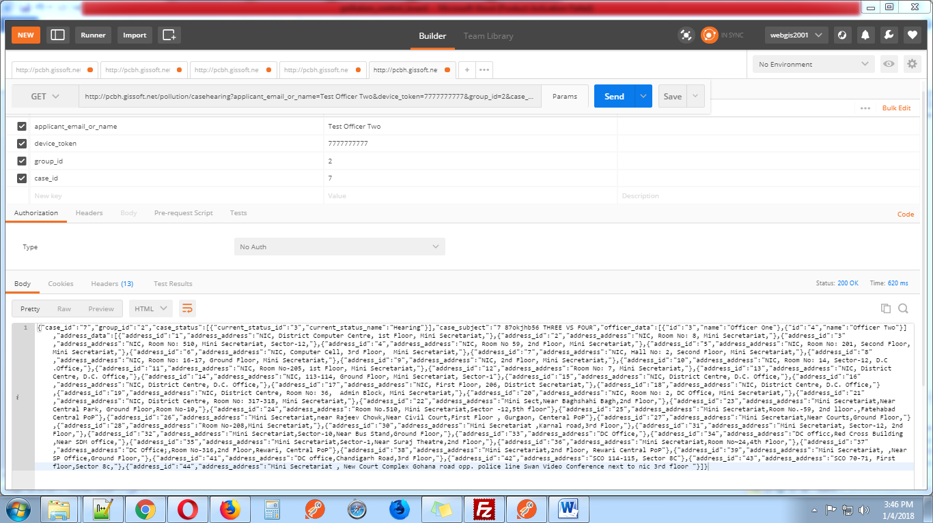

**20-** [**http://pcbh.gissoft.net/pollution/savecasehearing**](http://pcbh.gissoft.net/pollution/savecasehearing)

This web service use to assign case for hearing to officer this action do by super admin or admin

Send these parameters with post request for hearing

1. **applicant_email_or_name**
2. **device_token**
3. **group_id** (1 for super admin 2 for admin 3 for user)
4. **case_id**
5. **current_status_id (pass current_status_id 3 this id come from** [**http://pcbh.gissoft.net/pollution/casehearing**](http://pcbh.gissoft.net/pollution/casehearing)**)**
6. **officer_id (pass officer id this id come from** [**http://pcbh.gissoft.net/pollution/casehearing**](http://pcbh.gissoft.net/pollution/casehearing)**)**
7. **date (YYYY-mm-dd)**
8. **time_of_hearing (hh:mm:ss am/pm)**
9. **remark**
10. **address_id (pass address_id this id come from** [**http://pcbh.gissoft.net/pollution/casehearing**](http://pcbh.gissoft.net/pollution/casehearing)**)**

Send those parameters for edit hearing with post request.

Send these parameters with post request for hearing

1. **applicant_email_or_name**
2. **device_token**
3. **group_id** (1 for super admin 2 for admin 3 for user)
4. **case_id**
5. **hearing_id(pass hearing_id this id come from** [**http://pcbh.gissoft.net/pollution/caseedithearing**](http://pcbh.gissoft.net/pollution/caseedithearing)**)**
6. **current_status_id (pass current_status_id 3 this id come from** [**http://pcbh.gissoft.net/pollution/casehearing**](http://pcbh.gissoft.net/pollution/casehearing)**)**
7. **officer_id (pass officer id this id come from** [**http://pcbh.gissoft.net/pollution/casehearing**](http://pcbh.gissoft.net/pollution/casehearing)**)**
8. **date (YYYY-mm-dd)**
9. **time_of_hearing (hh:mm:ss am/pm)**
10. **remark**
11. **address_id (pass address_id this id come from** [**http://pcbh.gissoft.net/pollution/casehearing**](http://pcbh.gissoft.net/pollution/casehearing)**)**

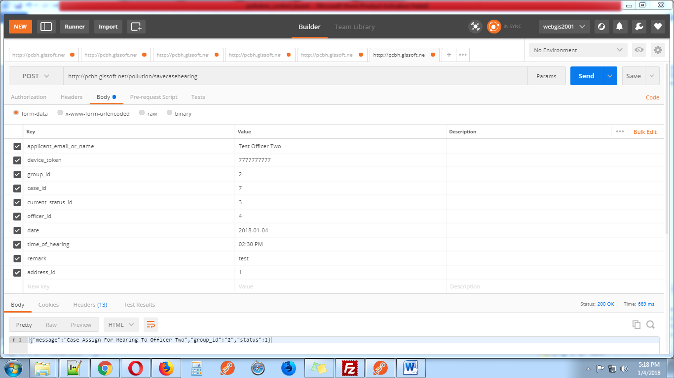

**21-** [**http://pcbh.gissoft.net/pollution/caseedithearing**](http://pcbh.gissoft.net/pollution/caseedithearing)

This web services use for edit hearing page do by super admin or admin.

Send these parameters with get request

1. **applicant_email_or_name**
2. **device_token**
3. **group_id** (1 for super admin 2 for admin 3 for user)
4. **case_id**

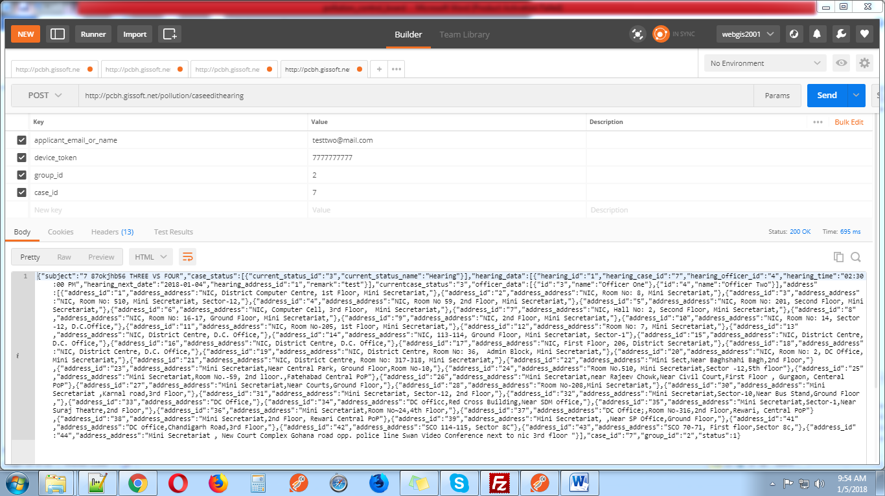

**22-** [**http://pcbh.gissoft.net/pollution/change_password**](http://pcbh.gissoft.net/pollution/change_password)

This web services use for edit password.

Send these parameters with post request.

1. **applicant_email_or_name**
2. **device_token**
3. **group_id** (1 for super admin 2 for admin 3 for user)
4. **password**
5. **confirm_password**

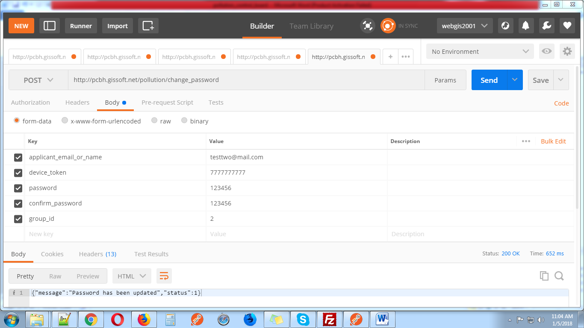

**23-** [**http://pcbh.gissoft.net/pollution/display_case_history**](http://pcbh.gissoft.net/pollution/display_case_history)

This web services display case history with case edit url for edit assign, edit hearing, edit dispose off, edit decided for super admin and admin.

Send these parameters with get request.

1. **applicant_email_or_name**
2. **device_token**
3. **group_id** (1 for super admin 2 for admin 3 for user)
4. **offset_num**
5. **limit_num**

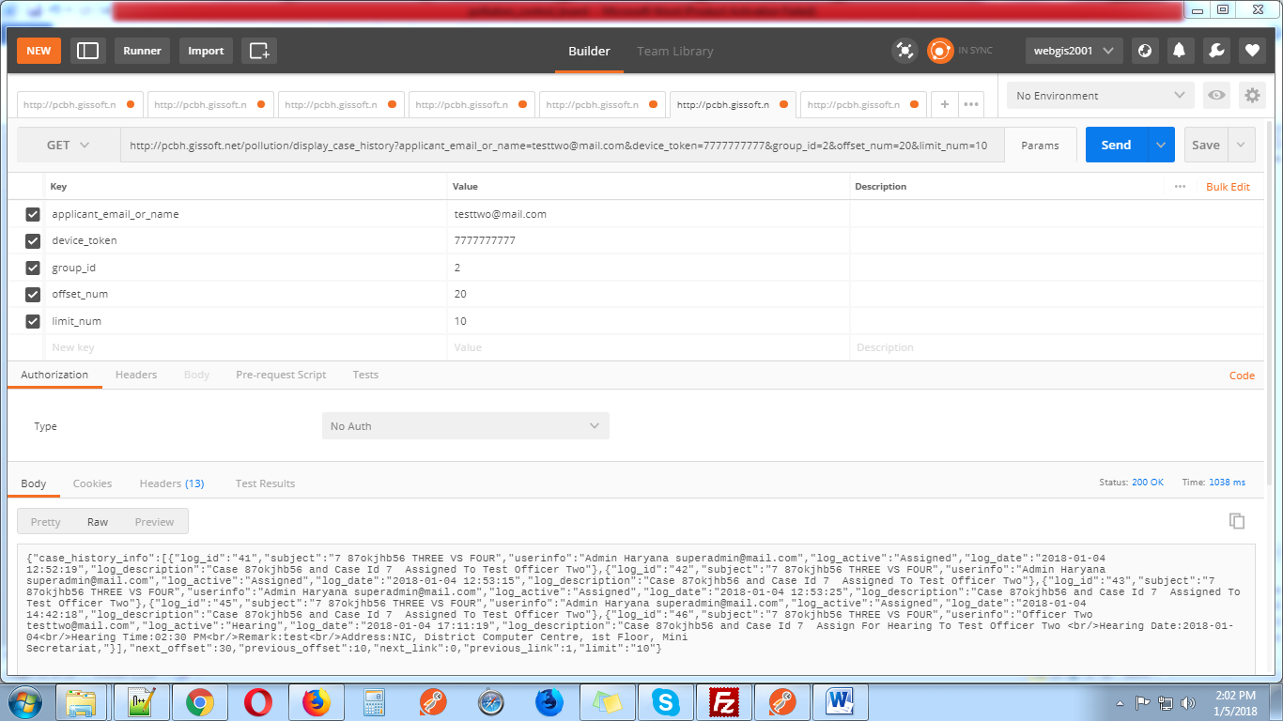

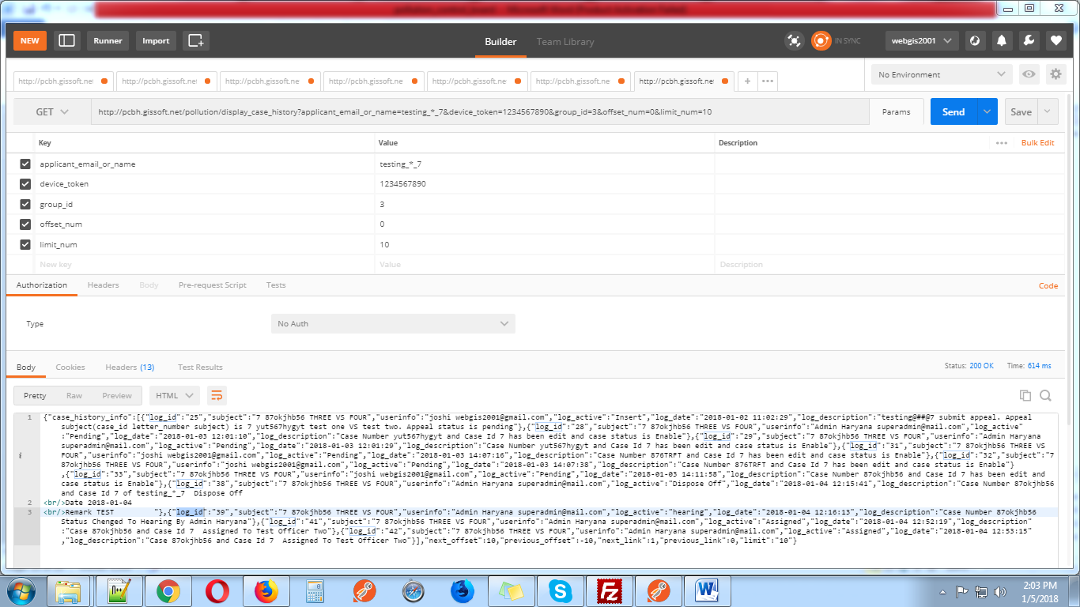

**24-** [**http://pcbh.gissoft.net/pollution/display_caseassign**](http://pcbh.gissoft.net/pollution/display_caseassign)

This web services use for display case assign for super admin with edit url for edit case assign when current status is Assigned.

Send these parameters with get request.

1. **applicant_email_or_name**
2. **device_token**
3. **group_id** (1 for super admin 2 for admin 3 for user)
4. **offset_num**
5. **limit_num**

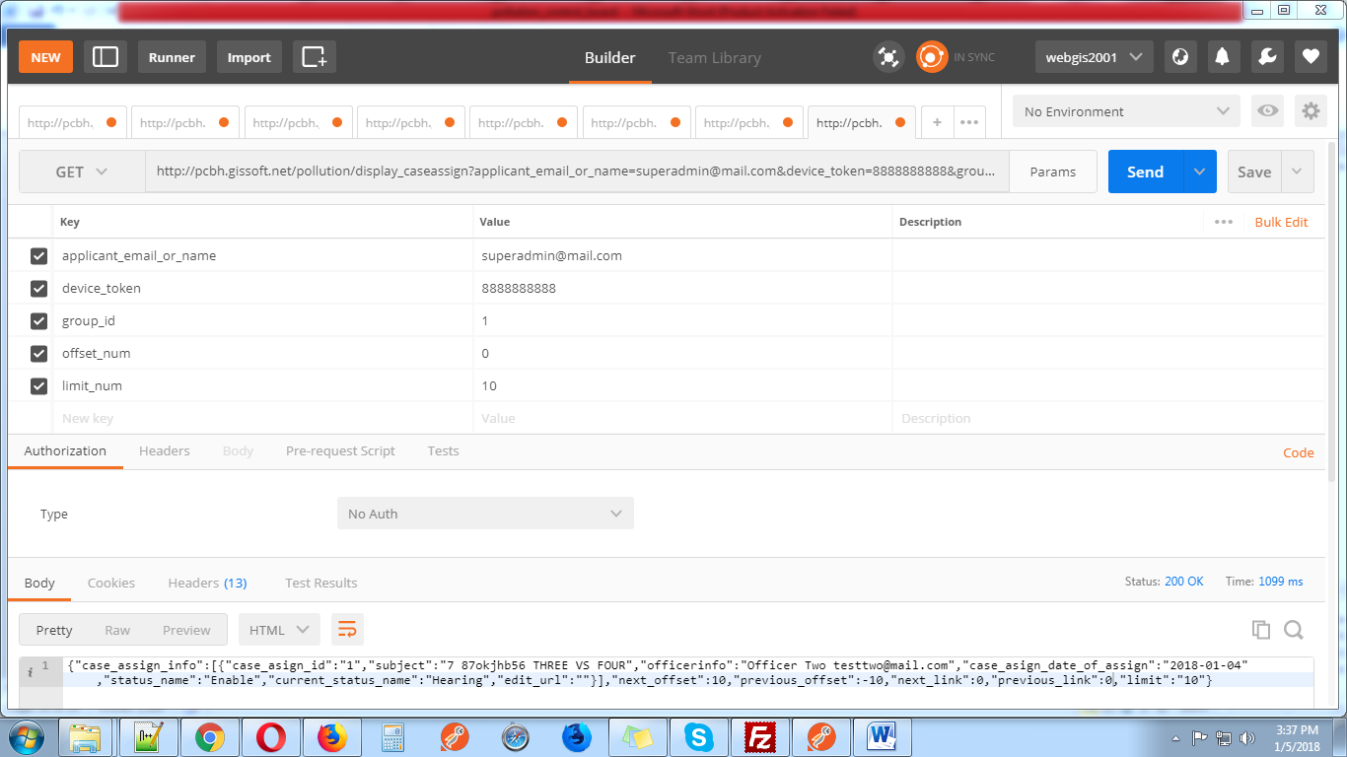

**25-** [**http://pcbh.gissoft.net/pollution/delete_caseassign**](http://pcbh.gissoft.net/pollution/delete_caseassign)

This web services use for delete assign case by super admin

Send these parameters with post request.

1. **applicant_email_or_name**
2. **device_token**
3. **group_id** (1 for super admin 2 for admin 3 for user)
4. **assign_id (case assign id get from** [**http://pcbh.gissoft.net/pollution/display_caseassign**](http://pcbh.gissoft.net/pollution/display_caseassign)**)**

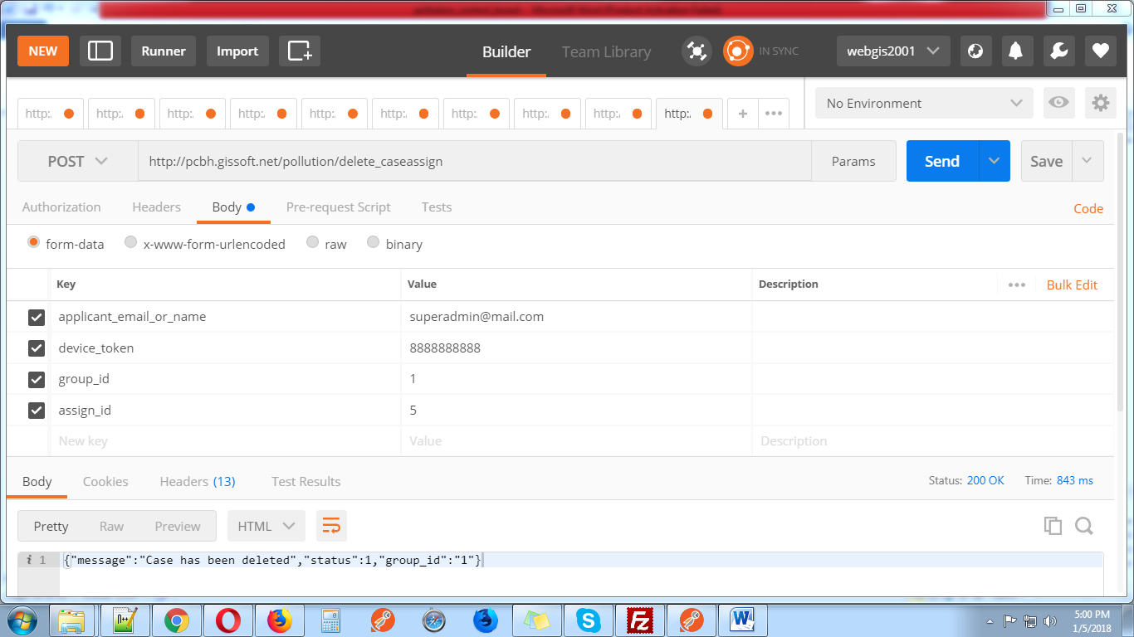

**26-** [**http://pcbh.gissoft.net/pollution/display_case_hearing**](http://pcbh.gissoft.net/pollution/display_case_hearing)

This web services use for display case hearing for super admin and admin

Send these parameters with get request.

1. **applicant_email_or_name**
2. **device_token**
3. **group_id** (1 for super admin 2 for admin 3 for user)
4. **offset_num**
5. **limit_num**

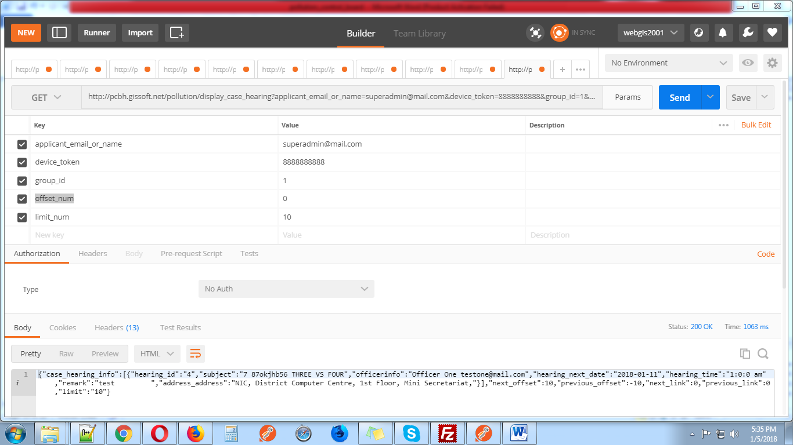

**27-** [**http://pcbh.gissoft.net/pollution/display_disposeoff**](http://pcbh.gissoft.net/pollution/display_disposeoff)

This web services use for display those cases which are disposedoff by super admin and admin.

Send these parameters with get request.

1. **applicant_email_or_name**
2. **device_token**
3. **group_id** (1 for super admin 2 for admin 3 for user)
4. **offset_num**
5. **limit_num**

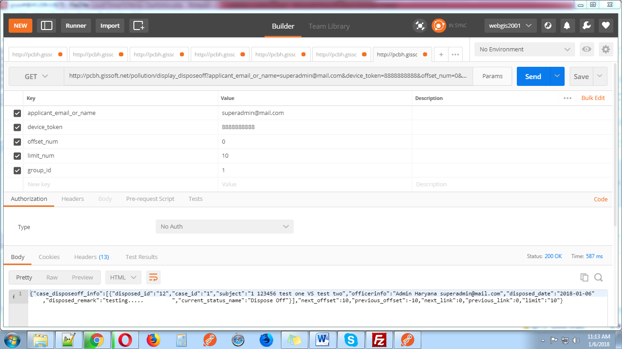

**28-** [**http://pcbh.gissoft.net/pollution/display_casedecided**](http://pcbh.gissoft.net/pollution/display_casedecided)

This web services use for display those cases which are decided by super admin and admin.

Send these parameters with get request.

1. **applicant_email_or_name**
2. **device_token**
3. **group_id** (1 for super admin 2 for admin 3 for user)
4. **offset_num**
5. **limit_num**

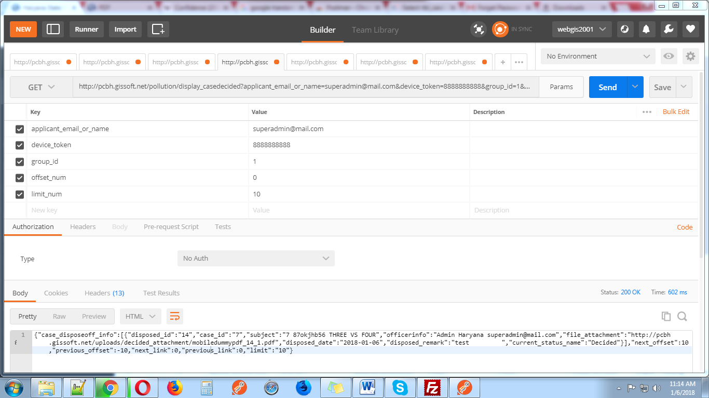

**29-** [**http://pcbh.gissoft.net/pollution/delete_casedecided_disposeoff**](http://pcbh.gissoft.net/pollution/delete_casedecided_disposeoff)

This web services use for delete those cases which are decided or disposedoff by super admin and admin.

Send these parameters with post request.

1. **applicant_email_or_name**
2. **device_token**
3. **group_id** (1 for super admin 2 for admin 3 for user)
4. **case_id (**case id received from <http://pcbh.gissoft.net/pollution/display_casedecided>for case decideand <http://pcbh.gissoft.net/pollution/display_disposeoff> for case dispose off**)**
5. **decided_disposeoff_id(**decided_disposeoff_id received from <http://pcbh.gissoft.net/pollution/display_casedecided>for case decideand <http://pcbh.gissoft.net/pollution/display_disposeoff> for case dispose off**)**

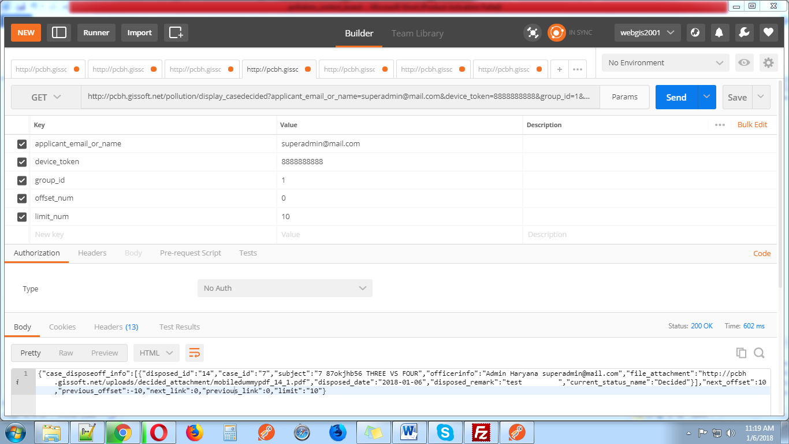

**30-** [**http://pcbh.gissoft.net/pollution/edit_casedecided_disposeoff**](http://pcbh.gissoft.net/pollution/edit_casedecided_disposeoff)

This web services use for edit those cases which are decided or disposedoff by super admin and admin.

Send these parameters with post request for edit disposedoff

1. **applicant_email_or_name**
2. **device_token**
3. **group_id** (1 for super admin 2 for admin 3 for user)
4. **decided_disposeoff_id(**decided_disposeoff_id received from <http://pcbh.gissoft.net/pollution/display_casedecided>for case decideand <http://pcbh.gissoft.net/pollution/display_disposeoff> for case dispose off**)**
5. **date (YYYY-mm-dd)**
6. **remark**

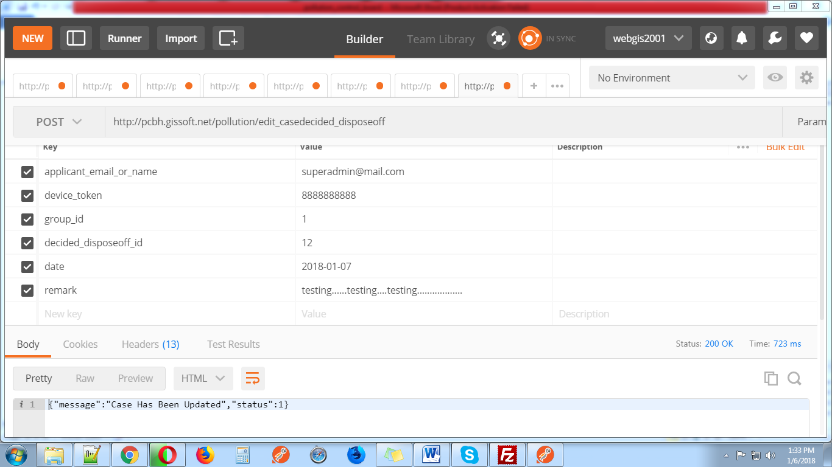

Send these parameters with post request for edit decided

1. **applicant_email_or_name**
2. **device_token**
3. **group_id** (1 for super admin 2 for admin 3 for user)
4. **decided_disposeoff_id(**decided_disposeoff_id received from <http://pcbh.gissoft.net/pollution/display_casedecided>for case decideand <http://pcbh.gissoft.net/pollution/display_disposeoff> for case dispose off**)**
5. **date (YYYY-mm-dd)**
6. **remark**
7. **attachment**

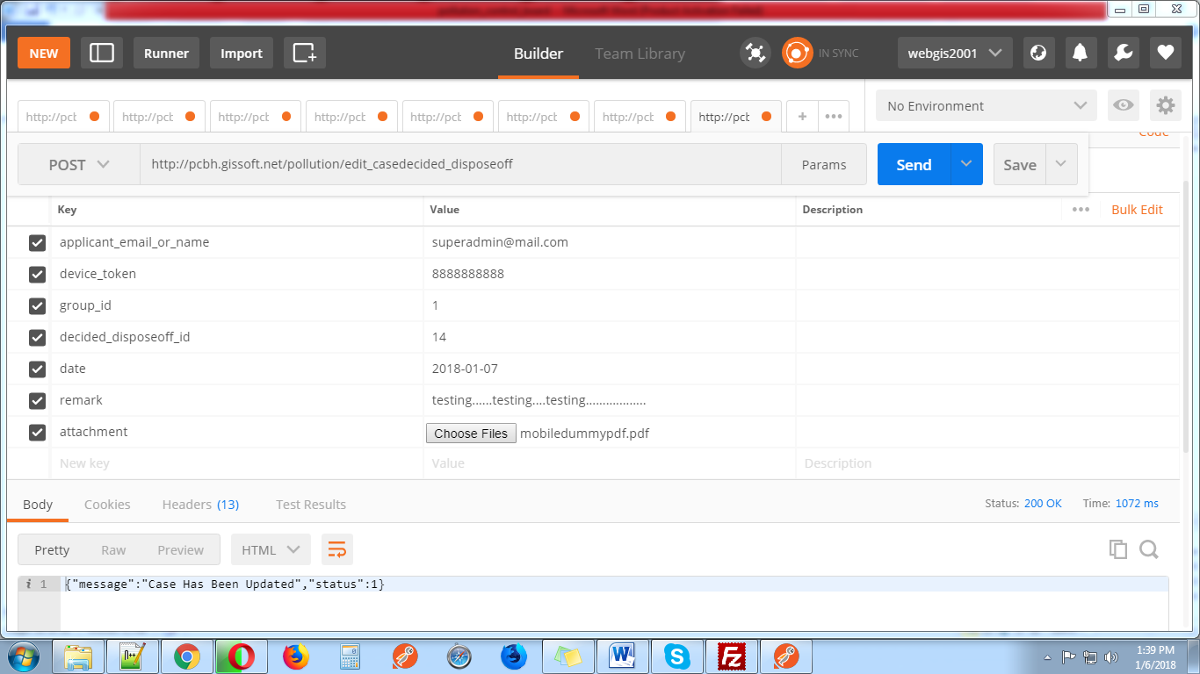

**31-** [**http://pcbh.gissoft.net/pollution/edit_page_casedecided_disposeoff**](http://pcbh.gissoft.net/pollution/edit_page_casedecided_disposeoff)

This web services use for display edit page of decided or disposedoff

Send these parameters with get request.

1. **applicant_email_or_name**
2. **device_token**
3. **group_id** (1 for super admin 2 for admin 3 for user)
4. **decided_disposeoff_id(**decided_disposeoff_id received from <http://pcbh.gissoft.net/pollution/display_casedecided>for case decideand <http://pcbh.gissoft.net/pollution/display_disposeoff> for case dispose off**)**

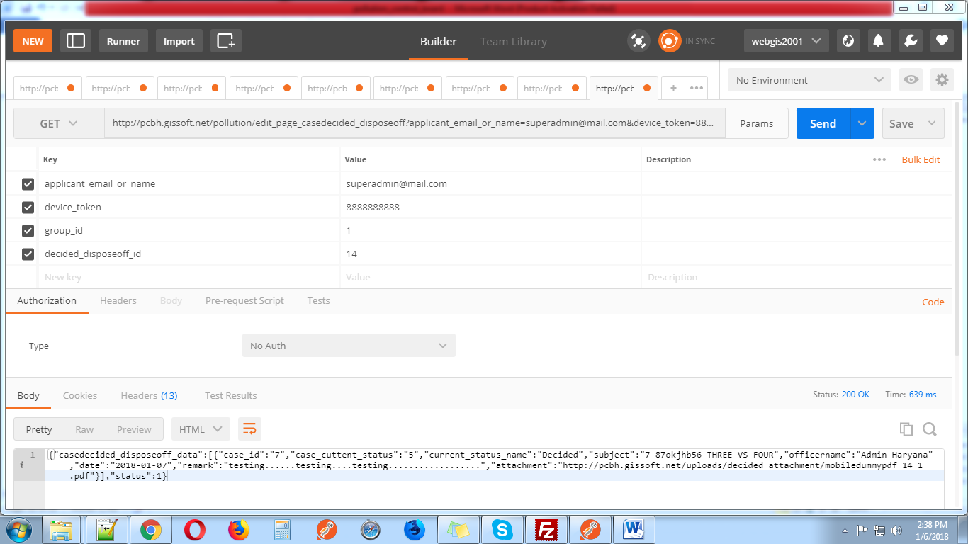

**32-** [**http://pcbh.gissoft.net/pollution/display_users**](http://pcbh.gissoft.net/pollution/display_users)

This web services use for display all users .Users display only for super admin.

Send these parameters with get request.

1. **applicant_email_or_name**
2. **device_token**
3. **group_id** (1 for super admin 2 for admin 3 for user)
4. **offset_num**
5. **limit_num**

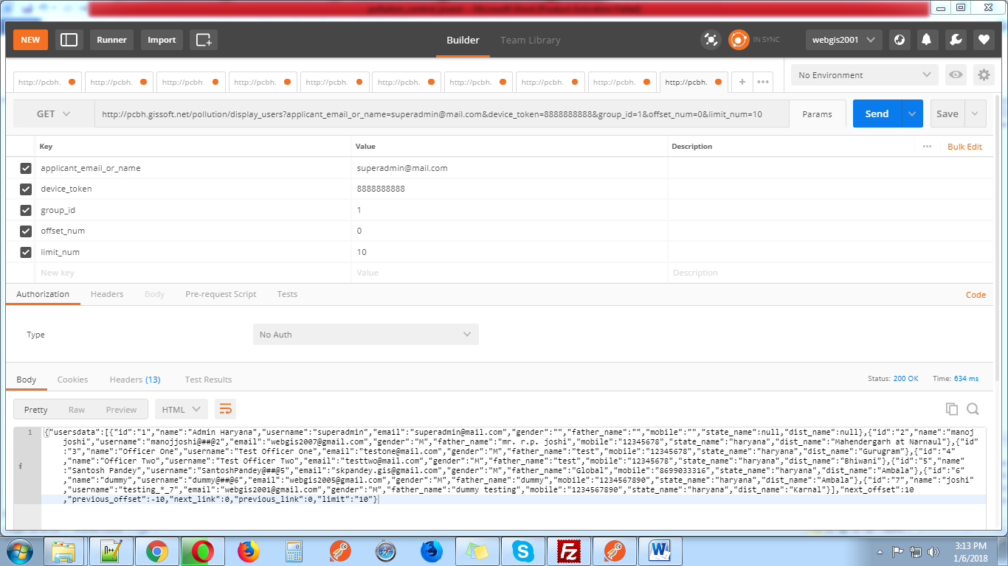

**33-** [**http://pcbh.gissoft.net/pollution/editcaseassign**](http://pcbh.gissoft.net/pollution/editcaseassign)

This web services use for display case assign for edit page.

Send these parameters with get request.

1. **applicant_email_or_name**
2. **device_token**
3. **group_id** (1 for super admin 2 for admin 3 for user)
4. **case_assign_id**

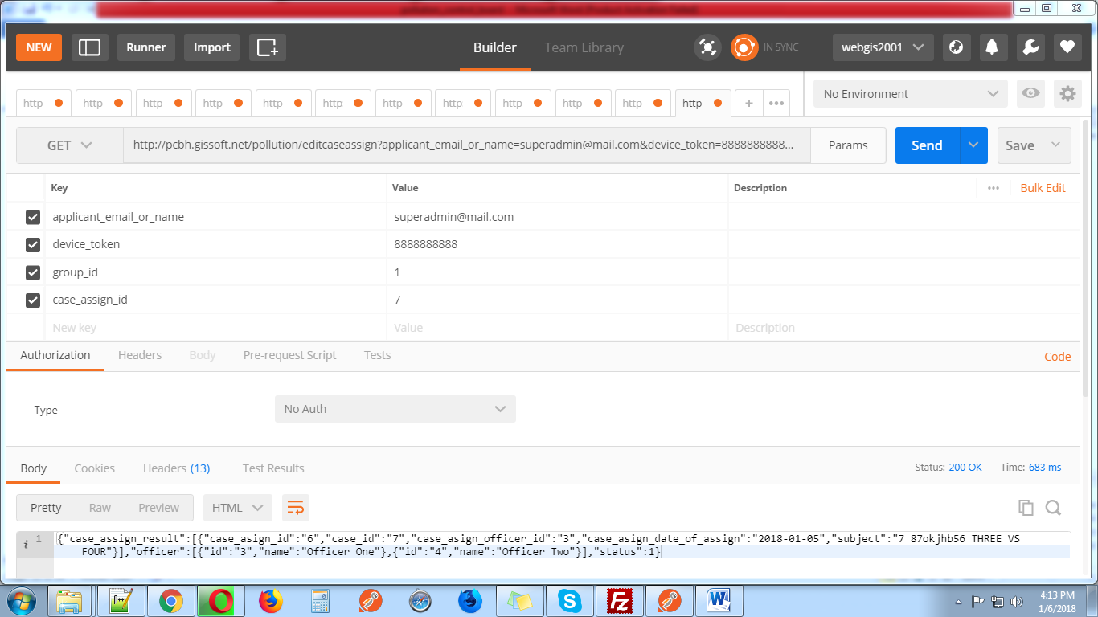

**34-** [**http://pcbh.gissoft.net/pollution/save_editcaseassign**](http://pcbh.gissoft.net/pollution/save_editcaseassign)

This web services use for update case assign for super admin only.

Send these parameters with post request.

1. **applicant_email_or_name**
2. **device_token**
3. **group_id** (1 for super admin 2 for admin 3 for user)
4. **case_assign_id**
5. **officer_id**
6. **date**

